Q1. Using JDBC, Execute a SQL query to fetch the attributes of the mobile with highest camera and lesser price from the mobile table.

Q2. Using JDBC, Execute a SQL query to fetch the name and brand of the mobile with the biggest screen size from the mobile table.

**package** MOB;

**import** java.sql.Connection;

**import** java.sql.DriverManager;

**import** java.sql.ResultSet;

**import** java.sql.SQLException;

**import** java.sql.Statement;

/**

*

* @author BHARATH R

*/

**public** **class** JDBC {

**static** **final** String ***DB_URL*** = "jdbc:mysql://127.0.0.1:3306/mobile_details?useSSL=false";

**static** **final** String ***USER*** = "BHARATHR";

**static** **final** String ***PASS*** = "9262112000";

**static** **final** String ***QUERY*** = "SELECT * FROM mobiles WHERE DISPLAY = (SELECT MAX(DISPLAY) FROM MOBILES);";

**public** **static** **void** main(String[] args) {

// Open a connection

**try**(Connection conn = DriverManager.*getConnection*(***DB_URL***, ***USER***, ***PASS***);

Statement stmt = conn.createStatement();

ResultSet rs = stmt.executeQuery(***QUERY***);

) {

**while**(rs.next()){

//Display values

System.***out***.print("ID:" + rs.getInt("id"));

System.***out***.print(", BRAND: " + rs.getString("BRAND"));

System.***out***.print(", NAME: " + rs.getString("NAME"));

System.***out***.print(", PRICE: " + rs.getString("PRICE"));

System.***out***.print(", DISPLAY: " + rs.getString("DISPLAY"));

System.***out***.print(", CAMERA: " + rs.getString("CAMERA"));

}

} **catch** (SQLException e) {

e.printStackTrace();

}

}

}

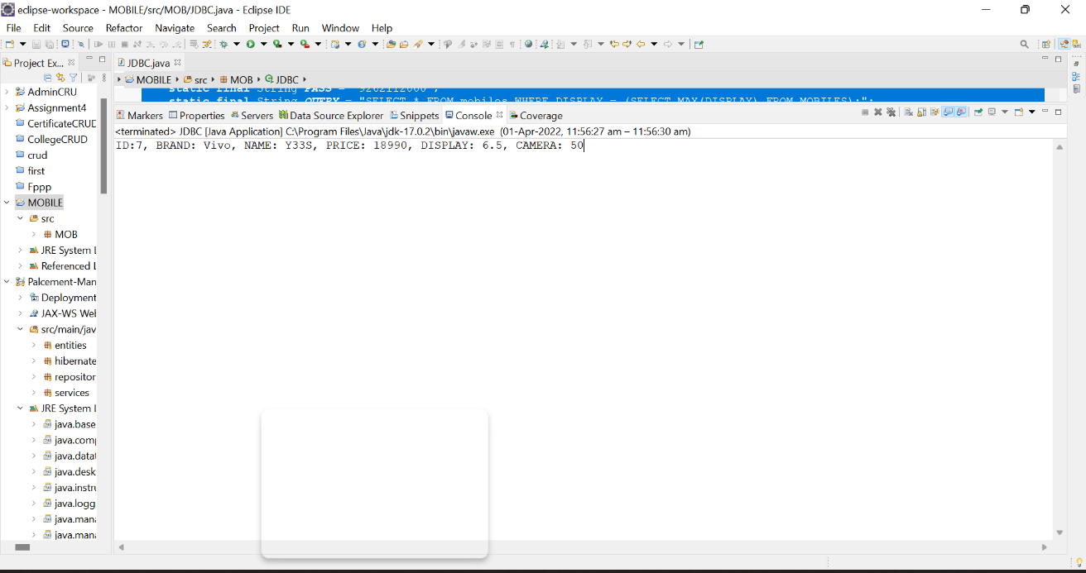

Q3. Using JDBC, Execute a SQL query to find the camera and price details of Apple Iphone 13 from the mobile table.

**package** MOB;

**import** java.sql.Connection;

**import** java.sql.DriverManager;

**import** java.sql.ResultSet;

**import** java.sql.SQLException;

**import** java.sql.Statement;

/**

*

* @author BHARATH R

*/

**public** **class** JDBC {

**static** **final** String ***DB_URL*** = "jdbc:mysql://127.0.0.1:3306/mobile_details?useSSL=false";

**static** **final** String ***USER*** = " BHARATHR";

**static** **final** String ***PASS*** = "9262112000";

**static** **final** String ***QUERY*** = "SELECT price, camera FROM mobiles WHERE BRAND = \"Apple\" and name=\"Iphone 13\";";

**public** **static** **void** main(String[] args) {

// Open a connection

**try**(Connection conn = DriverManager.*getConnection*(***DB_URL***, ***USER***, ***PASS***);

Statement stmt = conn.createStatement();

ResultSet rs = stmt.executeQuery(***QUERY***);

) {

**while**(rs.next()){

//Display values

System.***out***.print("PRICE: " + rs.getString("PRICE"));

System.***out***.print(", CAMERA: " + rs.getString("CAMERA"));

}

} **catch** (SQLException e) {

e.printStackTrace();

}

}

}

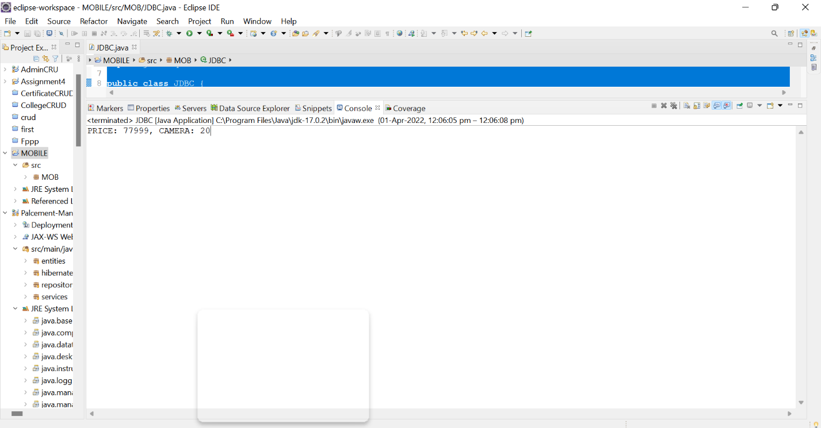

Q4. Using JDBC, Execute a SQL query to find the names and brands of all the phones with price from 10000 to 20000 and camera from 30-50 MP from the mobile table.

**package** MOB;

**import** java.sql.Connection;

**import** java.sql.DriverManager;

**import** java.sql.ResultSet;

**import** java.sql.SQLException;

**import** java.sql.Statement;

/**

*

* @author BHARATH R

*/

**public** **class** JDBC {

**static** **final** String ***DB_URL*** = "jdbc:mysql://127.0.0.1:3306/mobile_details?useSSL=false";

**static** **final** String ***USER*** = "BHARATHR";

**static** **final** String ***PASS*** = "9262112000";

**static** **final** String ***QUERY*** = "SELECT name,brand FROM mobiles WHere (price between 10000 and 20000) and (camera between 30 and 50) ;";

**public** **static** **void** main(String[] args) {

// Open a connection

**try**(Connection conn = DriverManager.*getConnection*(***DB_URL***, ***USER***, ***PASS***);

Statement stmt = conn.createStatement();

ResultSet rs = stmt.executeQuery(***QUERY***);

) {

**while**(rs.next()){

//Display values

System.***out***.print("NAME: " + rs.getString("NAME"));

System.***out***.print(", BRAND: " + rs.getString("BRAND"));

System.***out***.println();

}

} **catch** (SQLException e) {

e.printStackTrace();

}

}

}

